**NZ Covid-19 Statistics**

as of 8th July 2020

by Nitish Deshpande

**New Zealand Covid-19 Statistics**

This report aims to show insight into the numbers and details of the spread of Coronavirus (Covid-19) in New Zealand. The report displays stats from when the first case in New Zealand was reported, the 5th of March 2020. All data used has been gathered from the Ministry of Health website. Statistics about Covid-19 deaths are not included in this report. This report shows statistics as of 8th July 2020.

**Note:** All data has been manipulated and organised using MS Excel, Visual Studio SSDT, and T-SQL in SSMS. Visualisations have been created using MS Power BI.

**General Summary**

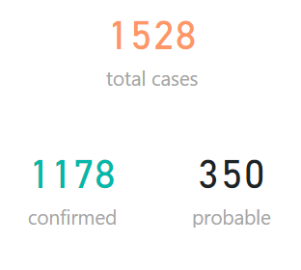

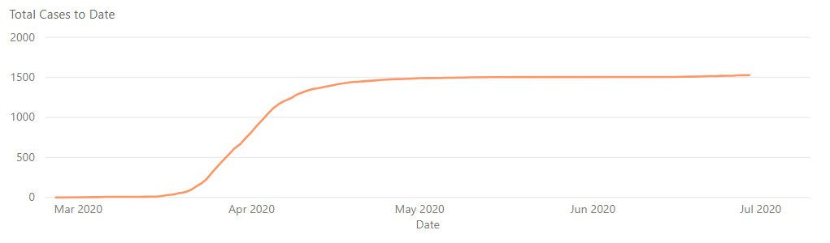

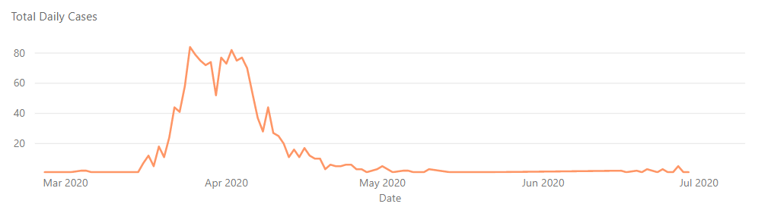

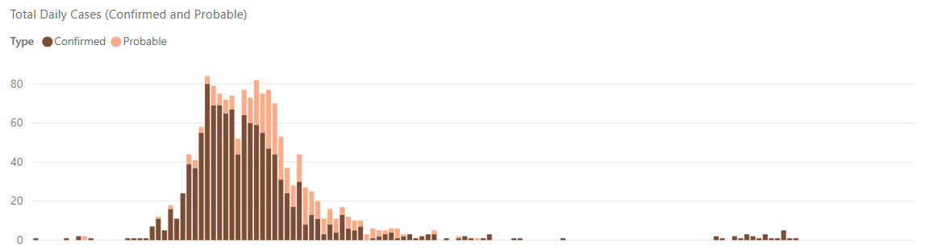

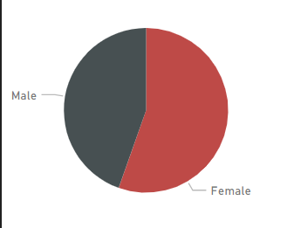**Gender Information**

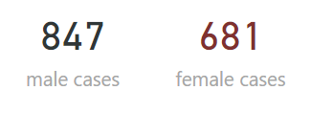

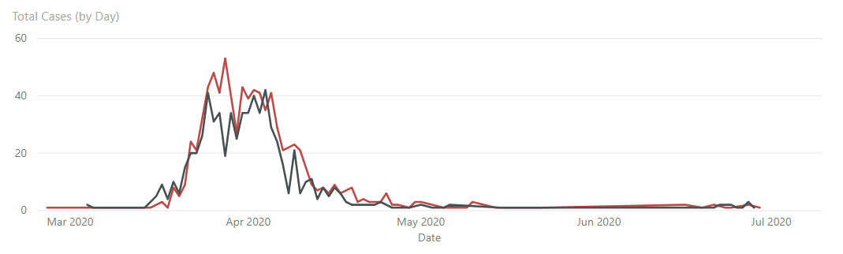

**Age Group Information**

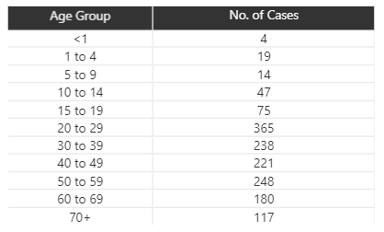

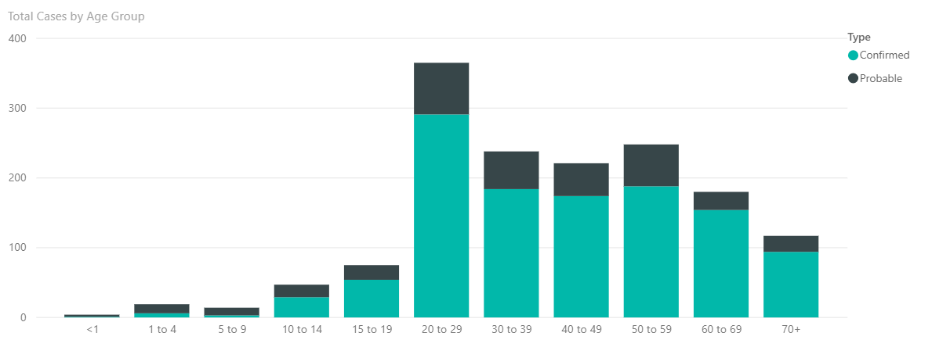

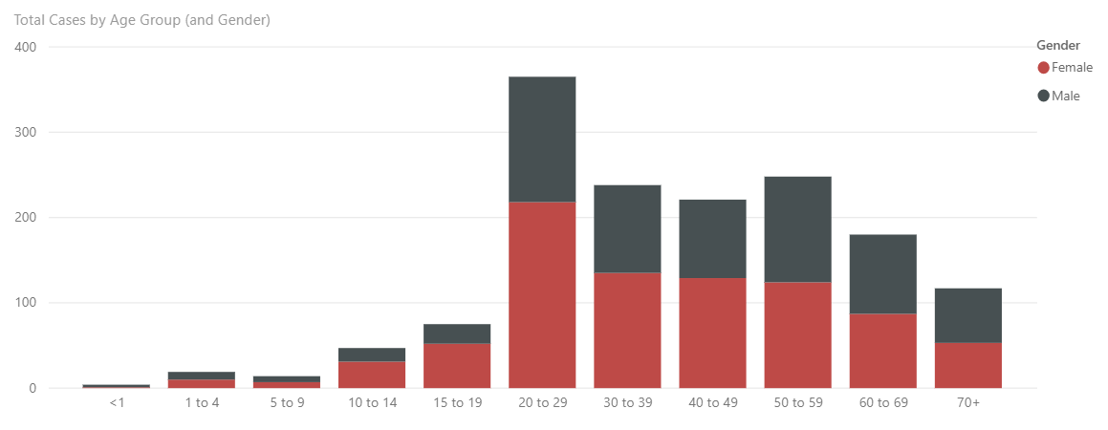

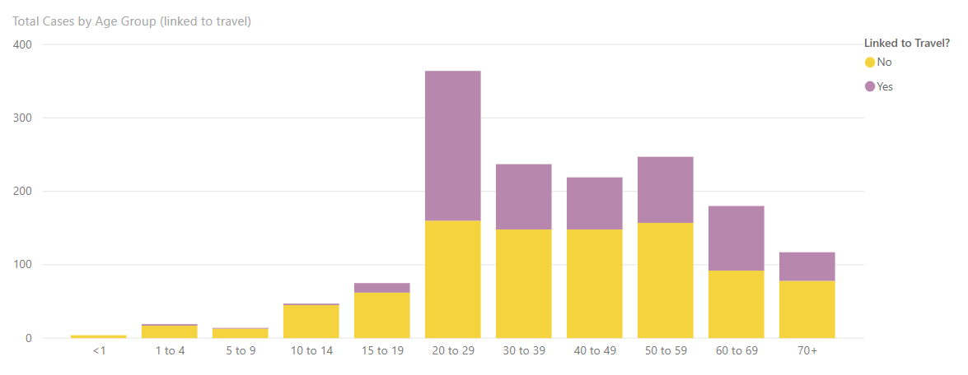

**Location Information**

